

**ÇANKAYA UNIVERSITY**

**FACULTY OF ENGINEERING**

**COMPUTER**   **ENGINEERING DEPARTMENT**

**Project Report**

**Version 2**

**CENG 408**

# SMART BOOKLET EMPOWERED BY AUGMENTED REALITY

Tuğçe ÇOBAN 201511015

Beyza KARAGÖZ 201511036

Edacan SEYREK 201511051

Deniz Berkay BIÇAK 201611403

Advisor: Öğr. Gör. Dr. Faris Serdar TAŞEL

Table of Contents

[SMART BOOKLET EMPOWERED BY AUGMENTED REALITY 1](bookmark://_Toc40436789#_Toc40436789)

[List of Figures 5](bookmark://_Toc40436790#_Toc40436790)

[Abstract 5](bookmark://_Toc40436791#_Toc40436791)

[1.Introduction 6](bookmark://_Toc40436792#_Toc40436792)

[1.1 QR CODE 6](bookmark://_Toc40436793#_Toc40436793)

[1.1.1 What is the QR code ? 6](bookmark://_Toc40436794#_Toc40436794)

[1.1.2 How to create QR code? 7](bookmark://_Toc40436795#_Toc40436795)

[1.1.3 Usage areas 7](bookmark://_Toc40436796#_Toc40436796)

[1.2 Augmented Reality 7](bookmark://_Toc40436797#_Toc40436797)

[1.2.1 What is Augmented Reality? 7](bookmark://_Toc40436798#_Toc40436798)

[1.2.2 Usage areas 8](bookmark://_Toc40436799#_Toc40436799)

[1.2.3 Advantages of Augmented Reality 8](bookmark://_Toc40436800#_Toc40436800)

[1.2.4 Disadvantages of Augmented Reality 8](bookmark://_Toc40436801#_Toc40436801)

[1.2.5 Peripherals used for Augmented Reality 9](bookmark://_Toc40436802#_Toc40436802)

[1.2.5.1 Hardware 9](bookmark://_Toc40436803#_Toc40436803)

[1.2.5.2 Software 9](bookmark://_Toc40436804#_Toc40436804)

[1.2.5.3 Marker 9](bookmark://_Toc40436805#_Toc40436805)

[Related Work 9](bookmark://_Toc40436806#_Toc40436806)

[Conclusion 10](bookmark://_Toc40436807#_Toc40436807)

[2.Software Requirements Specification 10](bookmark://_Toc40436808#_Toc40436808)

[2.1.1 Purpose of Project 11](bookmark://_Toc40436809#_Toc40436809)

[2.1.2 Scope of Project 11](bookmark://_Toc40436810#_Toc40436810)

[2.1.3 Glossary 11](bookmark://_Toc40436811#_Toc40436811)

[2.2. Overall Description 12](bookmark://_Toc40436812#_Toc40436812)

[2.2.1 Product Perspective 12](bookmark://_Toc40436813#_Toc40436813)

[2.2.2 Memory Constraints 12](bookmark://_Toc40436814#_Toc40436814)

[2.2.3 Operations 12](bookmark://_Toc40436815#_Toc40436815)

[2.2.4 Adaption Requirements 12](bookmark://_Toc40436816#_Toc40436816)

[2.2.5 Product Functions 12](bookmark://_Toc40436817#_Toc40436817)

[2.2.6 Constraints 13](bookmark://_Toc40436818#_Toc40436818)

[2.2.7 Assumptions and Dependencies 13](bookmark://_Toc40436819#_Toc40436819)

[2.3 Requirements Specification 13](bookmark://_Toc40436820#_Toc40436820)

[2.3.1 External Interface Requirements 13](bookmark://_Toc40436821#_Toc40436821)

[2.3.2 Functional Requirements 13](bookmark://_Toc40436822#_Toc40436822)

[2.3.3 Performance Requirements 16](bookmark://_Toc40436823#_Toc40436823)

[2.3.4 Software System Attributes 16](bookmark://_Toc40436824#_Toc40436824)

[2.3.4.1 Portability 16](bookmark://_Toc40436825#_Toc40436825)

[2.3.4.2 Performance 16](bookmark://_Toc40436826#_Toc40436826)

[2.3.4.3 Adaptability 16](bookmark://_Toc40436827#_Toc40436827)

[2.3.4.4 Usability 16](bookmark://_Toc40436828#_Toc40436828)

[2.3.5 Safety Requirements 16](bookmark://_Toc40436829#_Toc40436829)

[3.Software Design Document 16](bookmark://_Toc40436830#_Toc40436830)

[3.1 Introduction 16](bookmark://_Toc40436831#_Toc40436831)

[3.1.1 Purpose 16](bookmark://_Toc40436832#_Toc40436832)

[3.1.2 Scope 17](bookmark://_Toc40436833#_Toc40436833)

[3.1.3 Glossary 17](bookmark://_Toc40436834#_Toc40436834)

[3.1.4 Overview of Document 17](bookmark://_Toc40436835#_Toc40436835)

[3.1.5 Motivation 17](bookmark://_Toc40436836#_Toc40436836)

[3.2 Design Overview 18](bookmark://_Toc40436837#_Toc40436837)

[3.2.1 Description of Problem 18](bookmark://_Toc40436838#_Toc40436838)

[3.2.2 Architecture Design 18](bookmark://_Toc40436839#_Toc40436839)

[3.3 Use Case Realization 20](bookmark://_Toc40436840#_Toc40436840)

[3.3.1 Smart Booklet with AR System 20](bookmark://_Toc40436841#_Toc40436841)

[3.3.2 User Interface 21](bookmark://_Toc40436842#_Toc40436842)

[4.1 INTRODUCTION 28](bookmark://_Toc40436843#_Toc40436843)

[4.1.1 Version Control 28](bookmark://_Toc40436844#_Toc40436844)

[4.1.2 Overview 28](bookmark://_Toc40436845#_Toc40436845)

[4.1.3 Scope 28](bookmark://_Toc40436846#_Toc40436846)

[4.1.4 Terminology 28](bookmark://_Toc40436847#_Toc40436847)

[4.2 FEATURES TO BE TESTED 28](bookmark://_Toc40436848#_Toc40436848)

[4.2.1 Graphical User Interface (GUI ) 28](bookmark://_Toc40436849#_Toc40436849)

[4.2.2 DATABASE (DBS) 29](bookmark://_Toc40436850#_Toc40436850)

[4.2.3 Machine Learning Program (MLP) 29](bookmark://_Toc40436851#_Toc40436851)

[4.3 ITEM PASS/FAIL CRITERIA 29](bookmark://_Toc40436852#_Toc40436852)

[4.3.1 Exit Criteria 29](bookmark://_Toc40436853#_Toc40436853)

[4.4 REFERENCES 29](bookmark://_Toc40436854#_Toc40436854)

[4.5 TEST DESIGN SPECIFICATIONS 29](bookmark://_Toc40436855#_Toc40436855)

[4.5.1 Graphical User Interface(GUI) 29](bookmark://_Toc40436856#_Toc40436856)

[4 .5.1.1.1. Start(GUI.START_BTN) 29](bookmark://_Toc40436857#_Toc40436857)

[4.5.1.1.2 About Us(GUI.ABTUS_BTN) 29](bookmark://_Toc40436858#_Toc40436858)

[4.5.1.1.3 Exit (GUI.EXIT_BTN) 29](bookmark://_Toc40436859#_Toc40436859)

[4.5.1.2 Test Cases 30](bookmark://_Toc40436860#_Toc40436860)

[4.5.2.1 Subfeatures To Be Tested 30](bookmark://_Toc40436861#_Toc40436861)

[4.5.2.1.1Database Queries(DBS.DBQRY) 30](bookmark://_Toc40436862#_Toc40436862)

[4.6.1 Graphical User Interface (GUI) 32](bookmark://_Toc40436863#_Toc40436863)

[4.6.1.1 GUI.START_BTN.01 32](bookmark://_Toc40436864#_Toc40436864)

[Current Versions; 36](bookmark://_Toc40436865#_Toc40436865)

[5.Conclusion 38](bookmark://_Toc40436866#_Toc40436866)

[6.Acknowledgment 39](bookmark://_Toc40436867#_Toc40436867)

[7.References 39](bookmark://_Toc40436868#_Toc40436868)

# List of Figures

**Figure 1:** User Use Case Diagram

**Figure 2:** Smart Booklet Use Case Diagram

**Figure 3:** Sequence Diagram

**Figure 4:** Activity Diagram

**Figure 5:** Class Diagram

**Figure 6:** Application Architecture

**Figure 7:** Cover Page of the Smart Booklet

**Figure 8:** About Cankaya University

**Figure 9:** Computer Engineering

**Figure 10:** Laboratory

**Figure 11:** Why Cankaya University Computer Engineering?

**Figure 12:** Undergraduate Program

**Figure 13**: Academic Stuff

**Figure 14:** Contact Information

**Figure 15:** Back Cover

**Abstract**

Augmented reality is one of today's most popular topics. It is used in large fields such as marketing, real estate, decor, education, shopping, games, arts and museums, construction and so on. It is a technology that can be easily used as long as you have access to the Internet and the necessary applications. Augmented reality makes 3D feel like we are in a virtual universe. To date, traditional catalogs have only provided information in simple form in pictures and text. For this reason, with the catalog we will create using the augmented reality in our project, users can get information about all the content in the most realistic and detailed way. By reading the qr codes in the catalog, data such as photos, videos, maps and links are easily accessible.Our report contains some of the important methods each article. Keywords:Augmented reality, smart booklet,QR code,smart phones.

1. **Introduction**

We aim to provide more realistic and detailed content by using qr codes in our catalog created with augmented reality. People can access all the information about our department in detail using our catalog. Our catalog aims to provide detailed information in many areas such as general publicity, laboratories, academic staff, curriculum, student community, students, news and communication. In order to present our department in a detailed and realistic way, we provide access to various media data such as photos, videos, maps, links by using qr code. In order to show people our labs in the most realistic way, we offer 360 degree visualization, video and photo data for academic staff, links for viewing the curriculum, maps etc. for communication, augmented reality technology. Augmented reality has very rich libraries. Each library has different functions. To mention the important libraries for us; ARCORE allows use on smartphones and tablets. Works on both ios and android. Wuforia; It allows 3D objects to be defined and used in real time. Wikitude; Mobile is required for augmented reality. It has the function like 3D model creation and video settling. In our catalog, we aimed to introduce our computer engineering department in the most detailed and realistic way. The general introduction of our school will be on the entrance page of our catalog. General information and photos about our school will take place. When we go to the other pages, information about our teachers and laboratories can be reached. Information such as the names of our academic staff, professors, CVs, room numbers and the courses they give can be reached. On the other page, we aim to show you our 360 degree labs. As we aim to use augmented reality in various fields and in every field, we provide the most accurate information with a direct link on the page where we introduce our courses. In the communication part of our school, we use all media tools by placing maps.

**1.1 QR CODE**

**1.1.1 What is the QR code ?**

Technologies that make people's lives easier and make operations simple are increasing day by day. One of them is frequently used and one of the people's interest is QR code technology. A QR code (it stands for "Quick Response") is a mobile phone readable bar code that can store website URL's, plain text, phone numbers, email addresses and pretty much any other alphanumeric data. The most important feature of QR code is that it makes the flow of information faster. When you want to get more than the information you see on the banner, or you want to note the information you see, you can easily obtain, record and use it at any time thanks to your phone and internet access. In addition, you can reduce the transaction time to a minimum thanks to the QR code applications introduced by banking systems. In this respect, qr code can be considered as one of the most important visual elements by accelerating the information flow and minimizing the duration of the transactions. QR code has been approved as an AIM Standard, a JIS Standard and an ISO standard. In 2000 years, QR code is being issued as National standard in China.QR code data capacity; only numeric code Max. 7,089 characters , alphanumeric Max. 4,296 characters , binary (8 bits) Max. 2,953 characters ,Kanji / Kana Max. 1,817 characters. The number of rows of the QR code is equal to the number of columns. The minimum size of the Row / Column is 20 and the maximum size is 177 points.

**1.1.2 How to create QR code?**

We can create our QR code in a very simple way by using sites such as Kaywa QR-code, QR Stuff and ZXing Generator. Select the type of content you are promoting. Enter your data in the form that appears. You can create dynamically and statically. Dynamic Qr codes can update content later, while static Qr codes remain content constant. With the create option, the QR code is immediately created, saved and used. One of the reasons QR code is preferred is that it is easily accessible. The generated code is placed in a magazine, poster, glass, etc. and people can access the information in seconds by scanning the QR code scanner applications that they downloaded to their smartphones.

**1.1.3 Usage areas**

QR code has a wide range of applications. According to the data embedded in the code, users can take various actions: they can be directed directly to a web page with the help of a link, send a text message to a phone number or send an e-mail to a defined e-mail address. Companies use this technology in various markets and areas in order to increase sales and attract customers. To give a few examples to these studies: People can watch the trailer of the movie with the code placed on the movie poster, the interest in the product is increased by placing it on billboards, and it gives detailed information about the product by placing it in menus or brochures or it can directly sell that product, museums can be put on the screens to provide an audio tour. Some universities and companies used in catalogs, libraries and books. The University of Huddersfield is also one of the universities using this technology. By combining the physical world and the electronic world, they aimed at using technology in an easy way. For this, they shared the necessary and detailed information with the QR code they placed on physical libraries and printed materials with the users. Another way of use can be given to persons, location, telephone number, detailed information, pictures and videos about catalog. For example QR codes used in the Korean Journal of Urology. QR code is placed on the required pages. When the user scans the QR code, the video that is inserted into the code opens.

The usage area of the QR code should be expanded. It should be used wherever possible. It will be a great help for both publicity and information purposes in booklet to attract people's attention and provide a rich content visually. It helps helps banking transactions, promotions, advertising and more. QR technology is about to become a part of our lives with easy information flow and fast content provided to people.

**1.2 Augmented Reality**

**1.2.1 What is Augmented Reality?**

It is an advanced technology that enables the overlay of virtual objects such as audio, photos, videos, graphics or GPS over real images using the device's object recognition feature.It is a kind of real-time and interactive experience. So it improves existing reality and helps to adapt it to the real world we live in.Certain devices are needed to take advantage of this technology. For example smart glasses, smart phone etc. When you look at that object or material through these smart devices, the previously integrated applications show digital or electronic content in the real world. Augmented Reality applications can actually be described as animated QR codes. Augmented Reality was first partially acquired by a cinematographer. In 1957 Morton Heilig invented a tool called Sensorama. Sensorama has the features of giving audiences sound, visual, odor and vibration.

* In 1968, American computer scientist Ivan Sutherland and early Internet influence invented the head-mounted display as a kind of window into a virtual world.
* In 1975, an American computer artist, Myron Krueger developed the “virtual reality” interface in the form of op Videoplace, bu which enabled users to manipulate virtual objects and interact with them in real time.
* Steve Mann gave the world use of wearable computers in 1980.
* Thomas P Caudell of Boeing used the term “augmented reality ilk for the first time in 1990.
* The first truly working AR system was probably developed in 1992 by Louis Rosenberg at the Research Laboratory of USAF Armstrong. This was called Virtual Fixture, and it was an incredibly complex robot system at the same time as high speed. In the early 90s.
* In 2000, Bruce Thomas developed an outdoor mobile AR game called ARQuake.
* ARToolkit (a design tool) was launched in 2009 in Adobe Flash
* In 2013, Google announced the open beta version of Google (a mixed project).
* Microsoft announced augmented reality support and augmented reality headset HoloLens in 2015

**1.2.2 Usage areas**

The uses of augmented reality are highly developed. It is actively used in many fields such as marketing, real estate, shopping, games, cinema, device installation and repair, decoration, tourism and education. * / teknolo.com Especially with Pokemon Go mobile game published in 2016, millions of users all over the world became acquainted with Augmented Reality technology. In 2017, ARKit and ARCore Slam SDKs were released by Apple and Google in turn. In this way, both commercial and many independent game developers began to develop AR applications more easily. It was seen that the students achieved much more success with the use of education.A lot of work was done in areas such as advertising, furniture. These studies were enough to make people love the purified reality.

**1.2.3 Advantages of Augmented Reality**

* It can be used in the concretization of abstract concepts.
* It adds realism to the applications.
* Augmented reality applications provide enriched materials.
* It increases students' interest and motivation in the field of education. It also improves perception and facilitates easy learning.
* In the commercial sector, people have the opportunity to experiment with objects in the same environment.

**1.2.4 Disadvantages of Augmented Reality**

* The lack of some features on the devices we will use for our AR application leads to some restrictions. Memory, graphics power, processor facilities, internet facilities, etc. elements must be in sufficient condition in our device.
* AR applications are affected in the environmental conditions so the elements such as light and noise in the environment may adversely affect the AR application.
* Late detection of device responses at time of application, time constraints may prevent the application from running fully efficient.
* Devices with augmented reality applications (HoloLens, Google Glass, etc.) have high financial value.

**1.2.5 Peripherals used for Augmented Reality**

**1.2.5.1 Hardware**

For AR, hardware infrastructure and full use of users is very important to fulfill the given task. Alan B. Craig, in his book, Understanding Augmented Reality: Concepts and Applications, has divided the hardware of AG systems into three basic components; sensors, processors, and imagers. Components needed for LV environments

1. Sensors for GPS and camera etc ..
2. Viewers for tablet or portable screen etc ..
3. Can be desktop or mobile PC for processors.

**1.2.5.2 Software**

Augmented reality requires an interface that can hold the virtual and the real environment together, and this interface is often designed and released by software companies themselves. There are many libraries including AR technology. They are divided into open source and commercial. ARToolKit is one of the most widely used and widely used software package library in open source software. ARToolKit, developed by Hirokazu Kato in 1999, Hirokazu Kato washington university HIT Laboratory (The Human Interface Technology), written in C, with support in different languages.

1. **2.5.3 Marker**

Pointers are a tool for combining virtual and real environments.Pointer generation programs are stored in pat files with a numerical value (color codes 0-255) that expresses the hue of each pixel in the pointer pattern. ARToolKit type pointers can be 16x16 or 32x32. This type of pointers should be in square format and 50 percent of the image taken by the camera must match the numerical values in files with the extension “pat kayıtlı stored in the system.

**Related Work**

* **Article Title:** Illustrative visualization of 3D planning models for augmented reality in liver surgery

link : <https://link.springer.com/article/10.1007/s11548-009-0365-3>

Augmented Reality also works for doctors in the field of health. They need 3-D images for surgeries and they get help from augmented reality for this, but this is not enough and they change the light techniques so that they reach the 3D image.

* **Article Title** :Multimedia Augmented Reality Interface for E-learning (MARIE) Fotis Liarokapis, Panos Petridis, Paul F. Lister & Martin White

link:<https://www.researchgate.net/profile/Fotis_Liarokapis/publication/216813923_Multimedia_Augmented_Reality_Interface_for_E-learning_MARIE/links/02e7e5167fbde0b5b0000000.pdf>

This project is about education. QR codes were used instead of books. The code is read, then students and teachers can see photos, videos and articles using special glasses. Teachers can change the content.

* **Article Title**: Web3D and augmented reality to support engineering education Fotis Liarokapis, Nikolaos Mourkoussis, Martin White, Joe Darcy, Maria Sifniotis, Panos Petridis, Anirban Basu & Paul F. Lister

link:<http://www.wiete.com.au/journals/WTE&TE/Pages/Vol.3,%20No.1%20(2004)/03_Liarokapis29.pdf>

The user writes the url of the presentation in a web browser and thus logs into the presentation. User will be able to access Web3D presentation in 3D. This system takes place with the Web browser embedded in ARIFLite. For example; a student first accesses multimedia content using ARIFLite from the start menu, but sees 3D models with Augmented Reality. To view the 3D model, the existing window is replaced with a different video window. The user can see the 3D model at the end of these operations and compare the models with their real state.

* **Article Title**: Enhancing the Tourism Experience through Mobile Augmented Reality: Challenges and Prospects

link:<https://journals.sagepub.com/doi/full/10.5772/51644>

Tuscany+ is a digital tourist guide. Fondazione Sistema is Toscana's first augmented reality application. The application is only available in Italian and English languages. By providing information from Google, Wikipedia and various websites, it provides information such as the city's food and beverage, nightlife, accommodation, and attractions. Currently there is only iOS. Basel is another city that uses this digital tourist guide. However, the Baselin app is also available on iOS, Android, Blackberry iOS and Symbian Os. Users receive information about Basel's shopping malls, museums, entertainment venues, hotels, restaurants, etc. This information is taken directly from Baselin's database. Unlike Tuscany+, it serves in many languages. Information is available in German, French, Spanish and English.

* **Article Title**: Augmented Reality in Surgery link:<https://jamanetwork.com/journals/jamasurgery/article-abstract/396410>

**Conclusion**

Augmented reality has become a technology we encounter in every aspect of our lives. QR code is a visual technology that helps people with easy information flow, facilitating transactions and fast access. By combining these two technologies, we aim to promote our department in the best way. We will create a smart booklet with the most detailed and realistic information about our school and our department will have. With the researches and articles we have made, we have learned how to use the methods and programs in our project.

# Software Requirements Specification

###### 2.1 Introduction

### 2.1.1 Purpose of Project

Our goal is to create a catalog using augmented reality technology. In this catalog, we want to provide a detailed content using QR codes. We have a catalog target where visuality comes to the fore and combines with technology. For the time being, we will design the catalog on behalf of the computer engineering department. We want to create a detailed catalog system by taking into consideration the wishes of our teachers and students. In order to present the computer engineering department in a detailed and realistic way, we aim to provide access to various media data such as photos, videos, links by using QR code.When the user points the camera of the phone as well as the Qr code to the picture in the catalog, the video will be played on the phone. The video will be displayed to the user in the most realistic way.Catalog system for any company school etc. can be designed on behalf of.

Our primary goal is to make a more useful and understandable design.

### 2.1.2 Scope of Project

At the beginning of our project, we aimed to make a catalog system with improved visuality. We know that catalogs are an effective method for people. We strive to make this more effective. We aim to have sections of the catalog in itself. Each section has its own video, photo, link, 360 degree visuals etc. We aim to separate. Since our project is a computer engineering catalog for the time being, we chose to apply certain surveys to our teachers and students. We will continue to duplicate these options with our advisor. According to their results, the area of each section will be different. Our research shows that this system is not very common in the school catalog system. We wanted to spread it. We will continue to develop the project by combining more ideas and ideas.

### 2.1.3 Glossary

* **User:** Any person who use the smart booklet.
* **Qr code:** Quick Response code is the trademark for a type of matrix barcode which is a machine-readable optical label that contains information about the item to which it is attached
* **Android:** is a mobile operating system based on a modified version of the Linux kernel and other open source software, designed primarily for touchscreen mobile devices such as smartphones and tablets
* **iOS:** an operating system used for mobile devices manufactured by Apple Inc.
* **AR:** Augmented reality is an interactive experience of a real-world environment where the objects that reside in the real world are enhanced by computer-generated perceptual information, sometimes across multiple sensory modalities, including visual, auditory, haptic, somatosensory and olfactory.
* **360° Vr Videos:** 360-degree videos, are video recordings where a view in every direction is recorded at the same time, shot using an omnidirectional camera or a collection of cameras.
* **Virtual Tour:** A virtual tour is a simulation of an existing location, usually composed of a sequence of videos
* **Qr Scanner:** Qr Scanner display the code and converting it to some useful form
* **SRS:** Software Requirement Specification

## 2.2. Overall Description

### 2.2.1 Product Perspective

Smart catalog system is a system that can be used by any company and school. Users can easily access the information they want. He can move around the catalog any way he wants. Using augmented reality, it will reach a much more open catalog visually.We aim to make the catalog available in two ways. Play the video after swipe the QR code and zoom the camera to the picture. The catalog system will be divided into several sections. 360-degree visualization, video and photo maps, etc. to show people the most realistic catalog using QR code. We will offer augmented reality technology.

2.2.1.1 Development Methodology

We aim to use the visualizations at the highest level and integrate them with the user. We will develop a smart catalog on the web by taking advantage of the AR.js library. We will prepare a catalog using videos, links, photos. The libraries we use, which will be a system that can be opened on mobile, provide us this opportunity.

### 2.2.2 Memory Constraints

### 2.2.3 Operations

Users will scan the QR codes related to the content of the page with their smart phones. The contents embedded in the code will be displayed on the phone. If the content is a link, s/he can browse the referenced link. If it is a video, s/he can watch, and in the case of 360 videos, user can give direction as desired. If a map is embedded in the code, s/he can look at the address in detail. With the contents embedded in the code, the user will learn about what is introduced in the catalog thanks to the augmented reality and virtual reality. In the other hand,When you approach the picture from the catalog from your phone and tablet with internet connection, the video in the picture will be played on your device with augmented reality.

### 2.2.4 Adaption Requirements

Users should have smartphones or tablet with camera working well and access the internet. In

Android systems, versions 8 and 9 can automatically scan QR codes without an app. Some older Android versions require an app tos can QR codes. In iOS system, there is no need for any application. The device automatically sees the code without pressing the shutter button. When the camera recognizes the code, a notification appears to open the link in Safari.Users will be able to use the internet with the help of libraries we will use in augmented reality.

### 2.2.5 Product Functions

In smart booklet, user use two functions : Help,scanning Qr code and images with augmented reality. Help section: Describes how to use the booklet and for what purpose. Qr code scanning section:The user scans the Qr code with the smartphone / tablet. Whatever the content introduced on the page, the content that the user will see when the code is scanned will also be relevant. Depending on the content embedded in the code, the user will perform various functions. Image with augmented reality: The user points the camera of his phone at the picture. Thanks to the interaction of the camera, the picture is played back as a video.Reappears as picture when video is finished

Photo: Photos will be displayed in the phone will consist of a series of photos fluently. Video: the video on the page can be viewed. Map: You will have the most detailed information about the address information. 360 videos: A detailed, realistic and easily accessible video about the content introduced with Virtual Reality technology is displayed. Link: Redirected to website (Mostly used for non-visual or periodically updated topics)

### 2.2.6 Constraints

There may be constraints because of many things. Because of the user and the other half because of the system. First of all, the code needs to be scanned. And if the code cannot be scanned due to a user-generated problem, it cannot perform smart booklet functions.In the augmented reality, internet may be interrupted, the phone may play video heavily, or problems may arise if the camera is not approached at the right angle to the picture. System-related error, the link placed in the code may be removed / corrupted or inaccessible for any reason.Another may have poor quality of the video or uploaded the wrong video into the picture.

### 2.2.7 Assumptions and Dependencies

User must have access the internet and smart phone or tablet. And their camera must be in good working order.

## 2.3 Requirements Specification

### 2.3.1 External Interface Requirements

**2.3.1.1 User Interfaces**

The user interface will be worked on iOs and Android sytsems. We use theme for booklet design.

**2.3.1.2 Hardware Interfaces**

The application works on Android, IOS mobile devices and tablets. No other hardware is required.

**2.3.1.3 Software Interfaces**

There are no external software interface requirements.

**2.3.1.4 Communications Interfaces**

User must have browser to connect to website. So s/he need to have internet connection

### 2.3.2 Functional Requirements

2.3.2.1 User Use Case Diagram

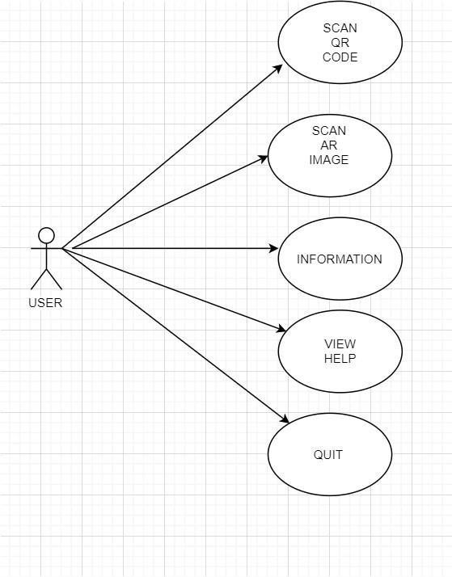

**Figure 1** User Use Case Diagram

Initial Step-By-Step Description:

1. Make sure your smartphone or tablet has internet access without the camera malfunctioning.
2. Point your phone / tablet to the screen to read the code.
3. Set the entire QR code to fit your screen.
4. If you haven't been able to successfully read the code from your phone / tablet, you can try reading another code.
5. Point your phone / tablet to the screen to read the image.
6. Move the camera so that it is parallel to the picture from above and the picture fits on the screen.
7. If you haven't been able to successfully read the video from your phone / tablet, you can try reading another image.
8. Returns to the picture when the video is finished.
9. You can sign out after reaching all the content you want.

Brief Description:

The main purpose of the smart booklet is to introduce Cankaya University Computer Engineering by reading QR codes or image with augmented reality with media content such as photos, videos, links, maps and 360 videos that we provide with augmented reality.

2.3.2.2 Smart Booklet Use Case Diagram

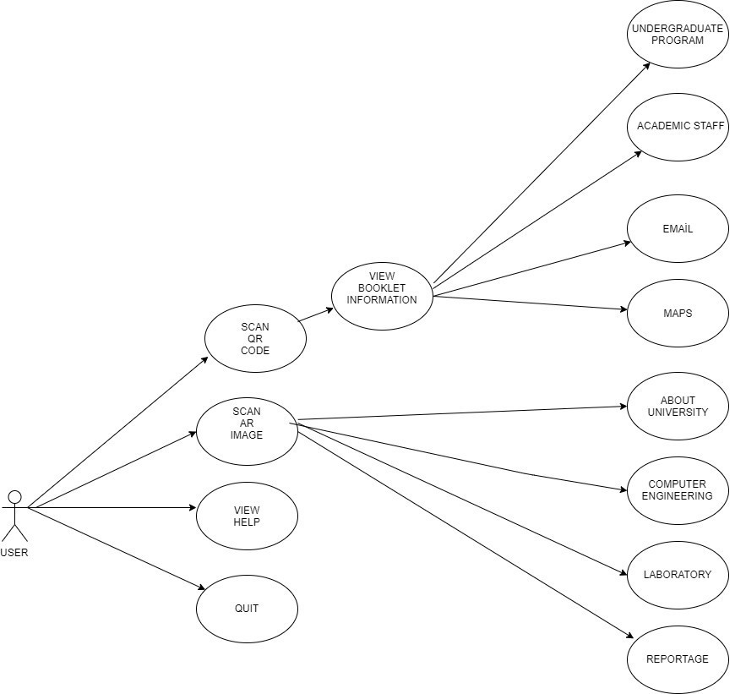

**Figure 2** Smart Booklet Use Case Diagram Brief Brief Description:

After starting to use the Smart Booklet, the user is given 3 options: 1.Scan QR code or image 2.View help 3.Quit First, you can review our catalog according to the information you want to reach. You can then scan our desired QR code to access our media with augmented reality inside. These media, photos, videos, links, maps, etc. is presented to you. If an error occurs in the QR code you have read, first make sure that your device is connected to the Internet, that the camera is working well and that you have read the QR code to fit the entire screen. If you are still unable to access content, you can try scanning another QR code. You can reach the information of how you can read QR code in our Help section.AR has been used on pages like cankaya university and computer engineering. the picture directly to the camera of your phone - parallel and 90º angle. The video uploaded to the picture will start playing on your device. When the video ends, you can access the AR content on the other page in the same way. After you reach the information you want, you can log out of the system.

### 2.3.3 Performance Requirements

When the SmartBooklet is paired with the smartphone / tablet camera with the image / QR code in the catalog, it will run smoothly. Nowadays, entry-intermediate phones can run the application with a low RAM. The application can run in a few seconds with low mb storage because it is able to run via internet connection.

* RAM: 2gb
* NETWORK: wifi/ lte /gsm /hspa
* MEMORY :50 mb
* PLATFORM : Android OS / iOS
* Chipset: Qualcomm MSM8974AC Snapdragon 652
* DISPLAY: No minimum requirement

### 2.3.4 Software System Attributes

#### 2.3.4.1 Portability

* All smartphones and tablets using ios and android operating system can use smart booklet.
* Internet connection required.

#### 2.3.4.2 Performance

* Fast internet connection is very important.
* There may be differences in display time depending on the size of the content.

#### 2.3.4.3 Adaptability

 The QR code should be compatible with Android and iOS system as it will open with a browser.

#### 2.3.4.4 Usability

* Each page will contain one or more QR codes or image with AR.
* The user will scan the code and display the page content with augmented reality technology.

### 2.3.5 Safety Requirements

There will be no security vulnerability as no personal data is received from users.

# 3. Software Design Document

## 3.1 Introduction

### 3.1.1 Purpose

Our goal is to create a catalog using augmented reality technology. Designing a different intelligent catalog system using QR codes in our catalogs. We want to create a new catalog system. We are currently designing this for the computer engineering department only. It will be a catalog rich in content and accessible to the desired information. In order to present the computer engineering department in a detailed and realistic way, we aim to provide access to various media data such as photos, 3D, videos, links using the QR code. The catalog will be presented to the user in the most realistic way. Our primary goal is to make a more useful and understandable design.

### 3.1.2 Scope

We wanted to use a more powerful visual in our project. Catalogs are one of the most effective methods for people. We want to make it more effective. QR codes in the catalogs with the help of video, 3D, links, etc. We wanted to design a visualized catalog. Nowadays such catalogs are widely used, but we have seen that it is not very common for schools and develop intelligent catalog system on behalf of the school.

### 3.1.3 Glossary

* **User:** Any person who use the smart booklet.
* **QR Code:** Quick Response code is the trademark for a type of matrix barcode which is a machine-readable optical label that contains information about the item to which it is attached
* **Android**: It is a mobile operating system based on a modified version of the Linux kernel and other open source software, designed primarily for touchscreen mobile devices such as smartphones and tablets.
* **iOS:** An operating system used for mobile devices manufactured by Apple Inc.
* **AR:** Augmented reality is an interactive experience of a real-world environment where the objects that reside in the real world are enhanced by computer-generated perceptual information, sometimes across multiple sensory modalities, including visual, auditory, haptic, somatosensory and olfactory.
* **Activity Diagram:** Activity diagram is defined as a UML diagram that focuses on the execution and flow of the behavior of a system instead of implementation.
* **Sequence Diagram:** A sequence diagram shows object interactions arranged in time sequence.
* **Class Diagram:** A class diagram in the Unified Modeling Language (UML) is a type of static structure diagram that describes the structure of a system by showing the system's classes, their attributes, operations (or methods), and the relationships among objects.
* **Qr Scanner:** Qr Scanner display the code and converting it to some useful form 
* **SDD:** Software Design Document

### 3.1.4 Overview of Document

This documentation contains software design information for the Smart Booklet Empowerted by AR. These details were determined by sequence diagram, activity diagram and class diagram. The design which is designed for the catalog is included in this catalog with all its pages.

### 3.1.5 Motivation

An exciting team that loves to develop. We think that augmented reality will add a lot to the future. Since we love to design, we wanted to combine our talents in this project. We aimed to improve ourselves with this project. In our project, we aimed to provide users with the most realistic content. With the smart booklet, people will be able to access the content in the catalog in a realistic manner not only by reading and passing a page, but also by means of their phones and software. For the time being, we present the computer engineering department of our school with all aspects (academic staff, laboratories, undergraduate program, etc.). However, we aim to implement this project in other areas in the future. We implement augmented reality and QR code technology in the project. Our project which will be used in smart phones and tablets will be able to work on operating systems such as Android and iOS.

## 3.2 Design Overview

### 3.2.1 Description of Problem

Today, most people are searching their catalogs in their free time or something they want, but they may be beyond their guess, because they can't really see it. Because of this problem, they did not use the catalog system very much. According to research on humans, they often use the catalog system to pass the time. We want to break this perception. So we want to get QR codes and photos, 3D images, the presentation we want.

### 3.2.2 Architecture Design

3.2.2.1 Simulation Design Approach

3.2.2.1.1 Sequence Diagram

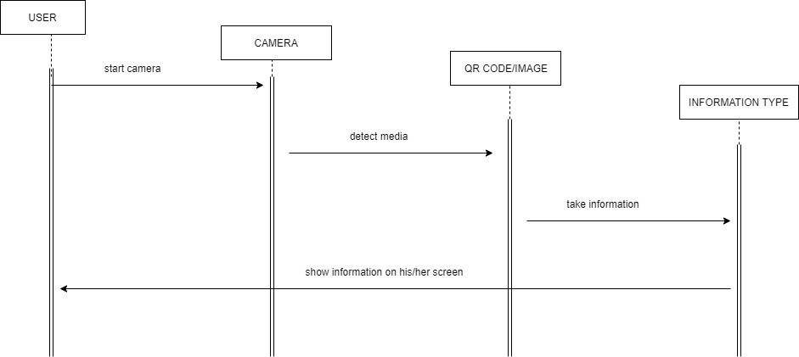

**Figure 3** Sequence Diagram

Figure 3: display the sequence diagram. First, the user turns on the camera. reads the QR code on the page or the camera according to the instruction on the page. The information given to the code or picture is received and shown to the user.

3.2.2.1.2 Activity Diagram

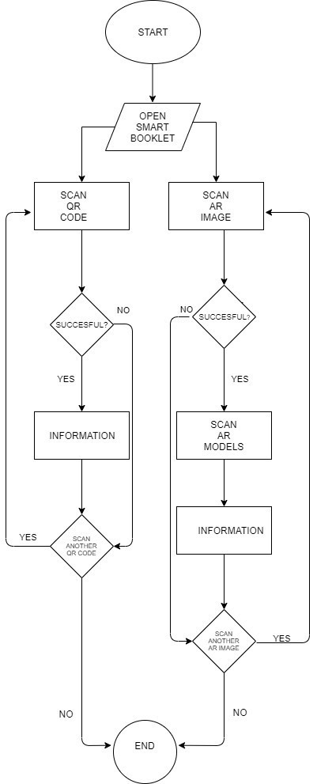

**Figure 4** Activity Diagram

Figure 4: display the activity diagram. The acitivity diagram shows how the application works. After opening the smart booklet, the user scans the QR code or image on the page to the camera of the phone. Retrieves content if successful. If not, it may try to scan another code or image. The application is terminated if it does not want to display any other content.

3.2.2.1.3 Class Diagram

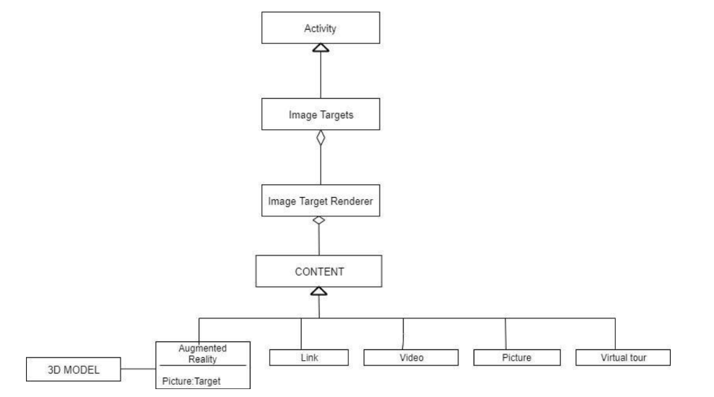

**Figure 5** Class Diagram

Figure 5: the class diagram shows the connection between the components. We can understand what is going on in the content, how to get to the activity section as shown in this diagram. **3.2.2.1.4 Application Architecture**

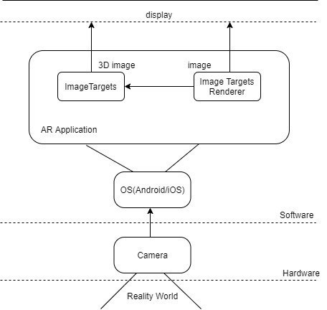

**Figure 6** Application Architecture

Figure 6, the architecture of our application is specified in general.

## 3.3 Use Case Realization

### 3.3.1 Smart Booklet with AR System

3.3.1.1 UI Design

**Cover page of the smart booklet:** A cover page that the user sees under any circumstances to access the catalog.

**About Cankaya University:** This page provides general information about the school. You can access the video content on this page using the QR code. In order to use the page without error, you must have internet access and smart device.

**Computer Engineering:** A general introduction to computer engineering. The user reads the QR using his smart device. Then you can access the video about the branches of computer engineering. To use the page without error, you must have internet access and smart device.

**Laboratory:** Users can see laboratories at school. In order to use the page without error, you must have internet access and smart device.

**Why Cankaya University Computer Engineering?** : When you read the QR code on the page, there is the answer to the question of choosing Cankaya University Computer Engineering. A short video is being played. Internet access and smart device must be used to use the page without errors

**Undergraduate Program:** This section contains content about undergraduate programs. We can read the QR code from the screen and then access the link. In order to use the page without error, you must have internet access and smart device.

**Academic Stuff:** After reading the QR code, information about academic staff is available. In order to use the page without error, you must have internet access and smart device.

**Contact Information :** Contact information is available for each campus of our school. There are 2 QR codes. You can reach the map, e-mail information with contact information. In order to use the page without error, you must have internet access and smart device.

**Back Cover:** Back cover page of the smart booklet.

3.3.1.2 Database Design

In our project, only the content that will be shown to the user will be kept in our database. These include video, photos, links and map information. There is no need for any user or admin information.

3.3.1.3 User Function Design

The User Function Describes the possible functions of the registered user. There are certain subsystems that allow users to access the content they want to login from the page cover. They can reach certain sub-sections such as getting information about the university and getting information about computer engineering. It is possible to read QR codes and access content such as video. Can be formatted according to requests.

### 3.3.2 User Interface

###### 1.Cover page of the Smart Booklet

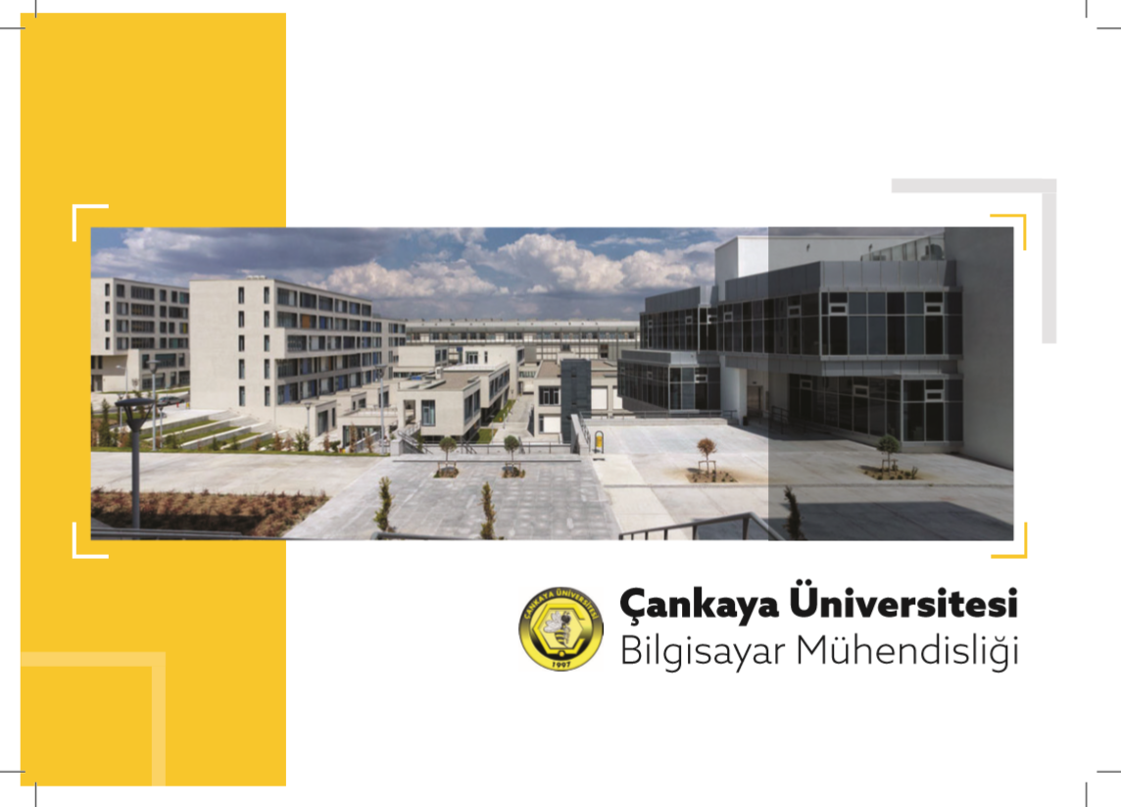

**Figure 7** Cover Page of the Smart Booklet

* **Summary:** Cover page of the smart booklet.
* **Actor:** User
* **Precondition:** None
* **Exception:** None
* **Post Conditions:** None
* **Priority:** Low

###### 2.About Cankaya University

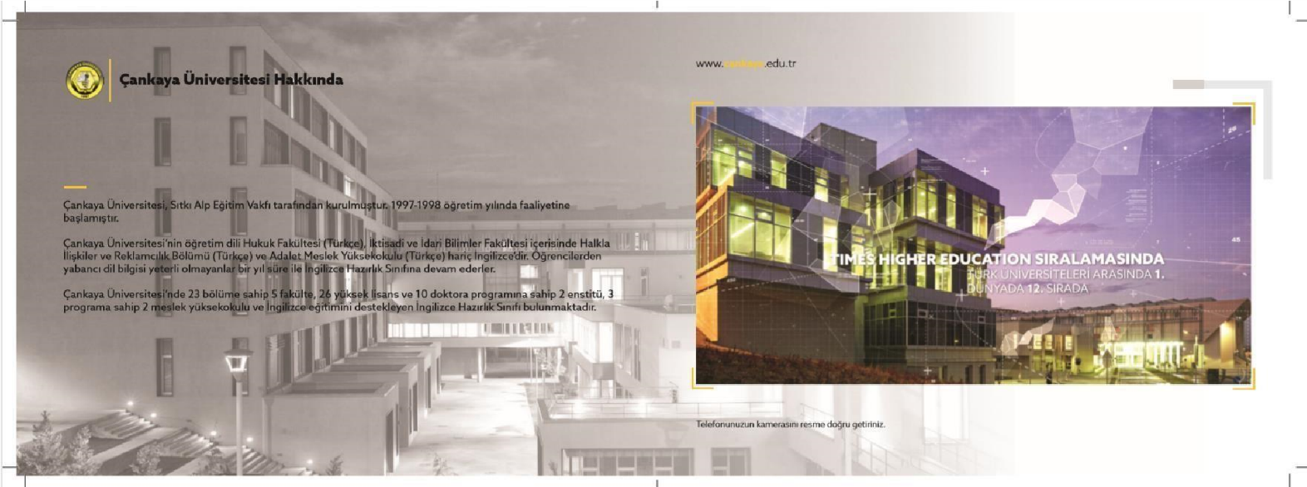

**Figure 8** About Cankaya University

* **Summary:** The page consist with general information about the school. The user can access the video on this page by reading his/her phone's camera.
* **Actor:** User
* **Precondition:** The smartphones/tablets and internet access.
* **Basic Sequence:**
* User must have smartphones/tablets and uninterrupted internet access.
* User should point the phone in a low and parallel way to the picture.
* If the application works correctly, the user will be able to view the video properly.
* **Exception:** The Internet connection may be lost or the AR may be a problem.
* **Post Conditions:** None
* **Priority:** High

###### 3.Computer Engineering

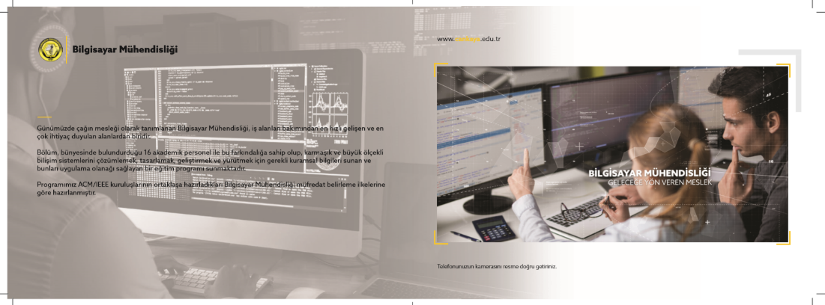

**Figure 9** Computer Engineering

* **Summary:** The page consist with general information about computer engineering. The user can access the video about branches of computer engineering on this page by reading his/her phone's camera.

###### Actor: User

* **Precondition:** The smartphones/tablets and internet access.
* **Exception:** The Internet connection may be lost or the AR may be a problem.
* **Post Conditions:** None
* **Priority:** High

###### 4.Laboratory

###### Figure 10 Laboratory

###### Summary: User can view labs in school in video. Actor: User Precondition: The smartphones/tablets and internet access. Exception: The Internet connection may be lost or the AR may be a problem. Post Conditions: None Priority: High

###### 5.Why Cankaya University Computer Engineering

**Figure 11** Why Cankaya University Computer Engineering?

* **Summary:** The answer to the question Why choose Çankaya University Computer Engineering is found in the video after reading the picture on the page.
* **Actor:** User
* **Precondition:** The smartphones/tablets and internet access.
* **Exception:** The Internet connection may be lost or the AR may be a problem.
* **Post Conditions:** None
* **Priority:** High

###### 6.Undergraduate Program

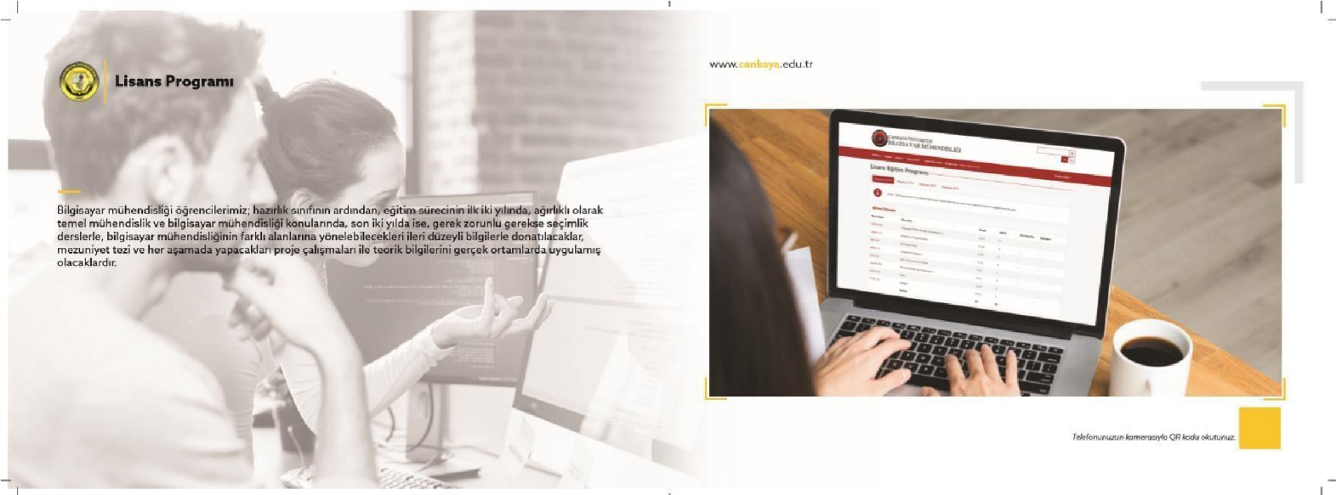

**Figure 12** Undergraduate Program

* **Summary:** Page contains information about the undergraduate program. Read the QR code on the page so that it fits perfectly on the screen. Thanks to the code you have read, you can find detailed information on the page from the link embedded in the code.



* **Actor:** User
* **Precondition:** The smartphones/tablets and internet access.
* **Basic Sequence:**

1. User must have smartphones/tablets and uninterrupted internet access.
2. The user should read the QR code on the page to fit the screen exactly on the phone.
3. After reading, the content embedded in the code can access the title of the current page.

* **Exception:** The Internet connection may be lost,code may not fit properly into camera or the links may be broken.
* **Post Conditions:** None
* **Priority:** High

###### 7. Academic Stuff

**Figure 13** Academic Stuff

* **Summary:** After the Qr code is read properly, detailed information about the academic staff will be available.
* **Actor:** User
* **Precondition:** The smartphones/tablets and internet access.
* **Exception:** The Internet connection may be lost,code may not fit properly into camera or the links may be broken.
* **Post Conditions:** None
* **Priority:** High

###### 8.Contact Information

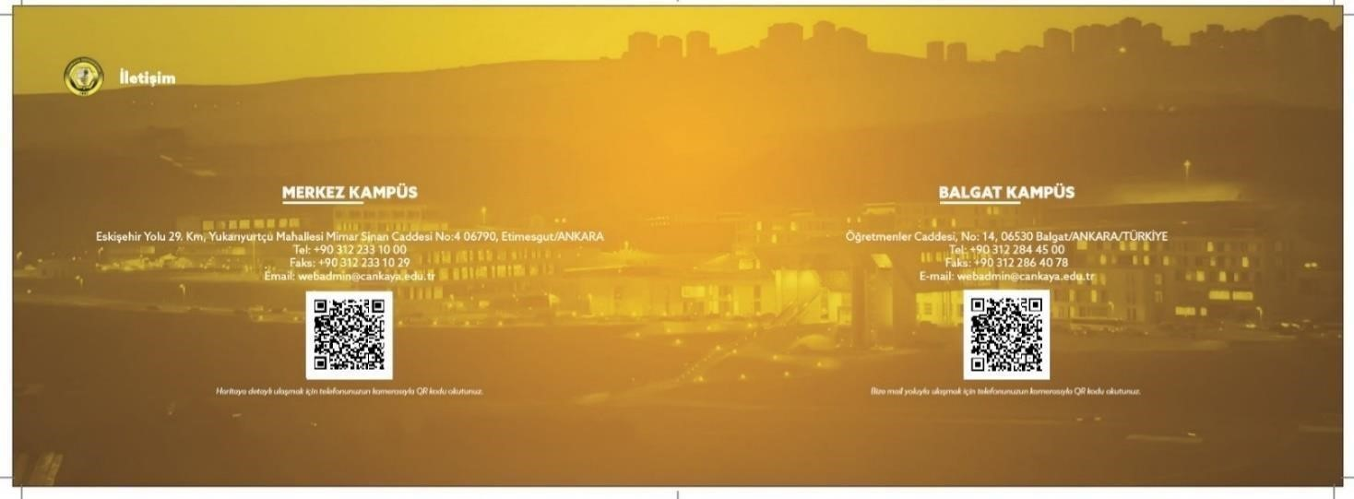 F  **Figure 14** Contact Information

* **Summary:** Contact and address information are available on both campuses of the school. There are 2 QR codes on this page. In one of them detailed map information can be accessed and in the other one can be e-mailed directly.
* **Actor:** User

**Precondition:** The smartphones/tablets and internet access.

* **Exception:** The Internet connection may be lost,code may not fit properly into camera or the links may be broken.
* **Post Conditions:** None
* **Priority:** High

###### 9.Back Cover

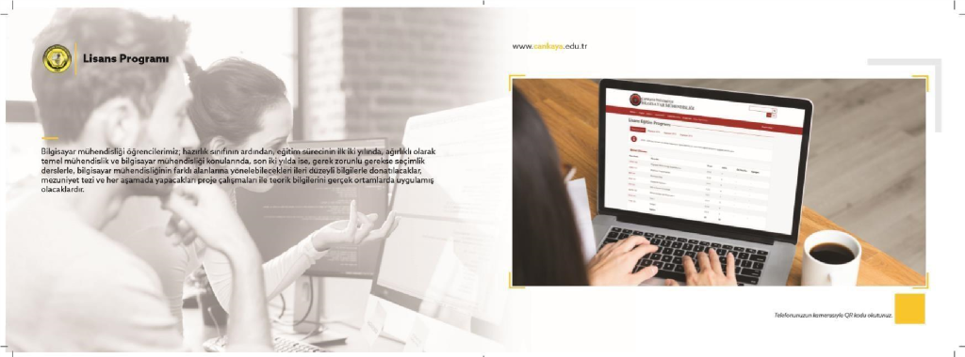 **Figure 15** Back Cover

* **Summary:** Back cover page of the smart booklet. **Actor:** User **recondition:** None.

1. **Exception:** None **Post Conditions:** None **Priority:** Low
2. **Test Plan, Test Design Specifications and Test Cases**

## 4.1 INTRODUCTION

### 4.1.1 Version Control

|  |  |  |
| --- | --- | --- |
| **Version No** | **Description of Changes** | **Date** |
| 1.0 | First Version | 03/20/2020 |

### 4.1.2 Overview

In the testing phase of our project, we want to present qr and augmented reality and information via pictures, videos and links from the catalog we designed. At the end of this test, we aim to show how useful our project is and to introduce our department that is intertwined with technology.

### 4.1.3 Scope

The efficiency of our project will be determined within the scope of this document. Briefly, it covers the topics on which our project has been tested. These topics

1.) Photograph, video, link 2.) QR recognition

3.) 3D image with augmented reality

### 4.1.4 Terminology

|  |  |
| --- | --- |
| **Acronym** | **Definition** |
| GUI | Graphical User Interface |
| ML | Machine Learning |
| API | Application Programming Interface |
| DBS | Database |

## 4.2 FEATURES TO BE TESTED

We aim to introduce our department in the best way in the catalog we designed. In our catalog, we introduce our department with links, photos and videos and we offer all the information to be reached by including sections such as curriculum, academic staff, interviews with graduates.

### 4.2.1 Graphical User Interface (GUI )

We presented the interface we designed in the project with our catalog. The requested information will be presented with the help of qr and ar with the sections we allocate such as academic staff, laboratories, interviews, curriculum.

### 4.2.2 DATABASE (DBS)

We are using Vufuria application to create our database.

### 4.2.3 Machine Learning Program (MLP)

We used ML part in our application in the image recognization part .If the image read to the camera has a similarity of 35% and above, the image, animation, video, sound that we have already embedded in the image in our database are displayed

## 4.3 ITEM PASS/FAIL CRITERIA

### 4.3.1 Exit Criteria

* 100% of the test cases are executed
* 90% of the test cases passed
* All High and Medium Priority test cases passed

## 4.4 REFERENCES

-SRS [Online] - https://github.com/CankayaUniversity/ceng-407-408-2019-2020- Smart-booklet-empowered-by-augmented-reality/wiki/Software-Requirements-Specification

-SDD [Online] - https://github.com/CankayaUniversity/ceng-407-408-2019-2020- Smart-booklet-empowered-by-augmented-reality/wiki/Software-Design-Document

## 4.5 TEST DESIGN SPECIFICATIONS

### 4.5.1 Graphical User Interface(GUI)

**4.5.1.1Subfeatures to be Tested**

#### 4 .5.1.1.1. Start(GUI.START_BTN)

User start the application.

#### 4.5.1.1.2 About Us(GUI.ABTUS_BTN)

User can learn about the users of the application.

#### 4.5.1.1.3 Exit (GUI.EXIT_BTN)

User can exit the application.

### 4.5.1.2 Test Cases

|  |  |  |  |
| --- | --- | --- | --- |
| **TC ID** | **Requirements** | **Priority** | **Scenario Description** |
| **GUI.START_BTN.01** | **6.1** | **H** | Open the camera to detect the object. |
| **GUI.ABTUS_BTN.01** | **6.2** | **L** | To get information about those who did that application. |
| **GUI.EXIT_BTN.01** | **6.3** | **H** | To exit to the application. |

**4.5.2 Database (DBS)**

### 4.5.2.1 Subfeatures To Be Tested

#### 4.5.2.1.1Database Queries(DBS.DBQRY)

We do not have any datebase system for the users. We can create our database system in backhand of the program thanks to using Vufuria application.We just only keep images,videos and animations in our database system.

|  |  |  |  |
| --- | --- | --- | --- |
| **TC ID** | **Requirements** | **Priority** | **Scenario Description** |
| DBS.DBQRY.01 | **3.1** | **H** | Includes content loaded on the application. Matches content to images. |

**4.5.3 Machine Learning Program(MLP) 4.5.3.1Subfeatures To Be Tested**

**4.5.3.1.1.Similarity(MLP.SIM)**

Vuforia compares to pictures in its own cloud.

**4.5.3.2 Test Cases**

|  |  |  |  |
| --- | --- | --- | --- |
| **TC ID** | **Requirements** | **Priority** | **Scenario Description** |
| MLP.SIM.01 | **3.1** | **H** | If the image read to the camera has a similarity of 35% and above, the image, animation, video, sound that we have already embedded in the image in our database are displayed. |

**4.6 DEATILED TEST CASES**

### 4.6.1 Graphical User Interface (GUI)

#### 4.6.1.1 GUI.START_BTN.01

|  |  |
| --- | --- |
| **TC_ID** | GUI.START_BTN.01 |
| **Purpose** | Start the application |
| **Requirements** | 3.1 |
| **Priority** | High. |
| **Estimated Time Needed** | 10 second |
| **Dependency** | Internet connection is enough to use it. |
| |  |  | | --- | --- | | **Procedure** | [A01] Press start in welcome screen [V01] Open the AR camera | | [A02] Image should be introduced to the camera [V02] The embedded image will comes to the screen | | **Cleanup** | - |   **Setup** | People who want to uıse that program just have to download the application. |

**4.6.1.2 GUI.ABTUS_BTN.01**

|  |  |
| --- | --- |
| **TC_ID** | GUI.ABTUS_BTN.01 |
| **Purpose** | To introduce ourselves |
| **Requirements** | 3.1 |
| **Priority** | Low |
| **Estimated Time Needed** | 5 second |
| **Dependency** | Internet connection is enough to use it. |
| **Setup** | People who want to uıse that program just have to download the application. |
| **Procedure** | [A01] Select about us button [V01] Read the text  [A02] Click the return button  [V02] Return to the welcome screen |
| **Cleanup** | Return to welcome screen |

**4.6.1.3 GUI.EXIT_BTN.01**

|  |  |
| --- | --- |
| **TC_ID** | GUI.EXIT_BTN.01 |
| **Purpose** | Exit application |
| **Requirements** | 3.1 |
| **Priority** | High. |
| **Estimated Time Needed** | 5 second |
| **Dependency** | Internet connection is enough to use it. |
| **Setup** | People who want to uıse that program just have to download the application. |
| **Procedure** | [A01] Click the Exit button [V01] Close the application |
| **Cleanup** | Exit |

#### ****Current Versions;****

SmartBooklet I.  
SmartBooKletwithAnimastion (soon)

Just download the application to run the project, then it is ready to use directly. Follow these steps to download the app.

**1)** Login to your store account according to the device you use.  
**2)** Find SmartBooklet application and press the download button.  
**3)** Open the app after downloading it to your phone and allow camera access.  
**4)** After opening the application, scan the SCAN locations in the catalog to your camera and revive the catalog.

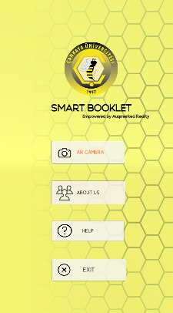

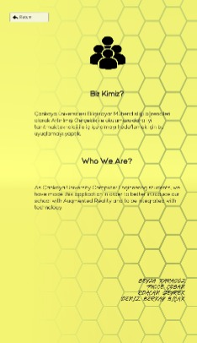

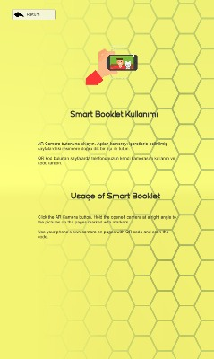

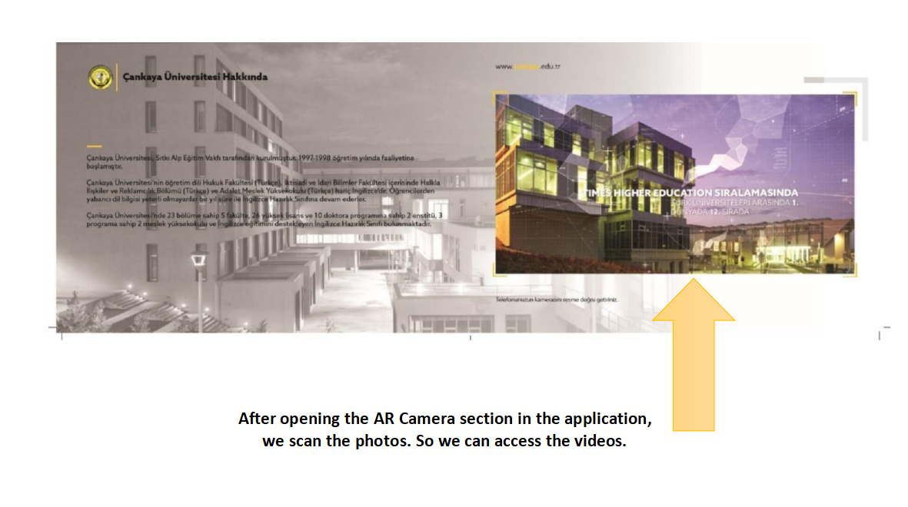

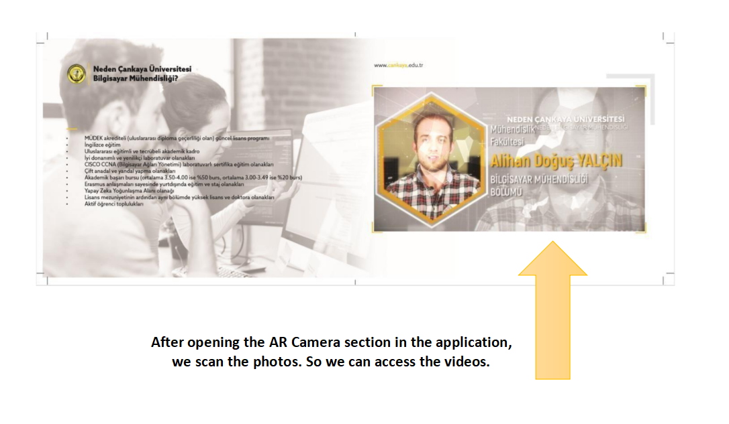

# Conclusion

Augmented reality has become a technology we encounter in every aspect of our lives. QR code is a visual technology that helps people with easy information flow, facilitating transactions and fast access. By combining these two technologies, we aim to promote our department in the best way. We will create a smart booklet with the most detailed and realistic information about our school and our department will have. With the researches and articles we have made, we have learned how to use the methods and programs in our project.

# Acknowledgment

We are happy to do our project with the advisor of Öğr. Gör. Dr. Faris Serdar TAŞEL.

Thanks for the help we have received from him, we will improve ourselves and our project.

# References

1. QR Stuff. (n.d.). What’s a QR code? Retrieved Nov. 14, 2010, from<http://www.qrstuff.com/>qr_codes.html
2. ISO/IEC 18004:2000. Information technology-Automatic identification and data capture techniques-Bar code Symbology-QR Code, 2000.
3. QR Code standard, GB/T 18284-2000, National standard of the People’s Republic of China:

Quick Response Code (in Chinese), Issued by China State Bureau of Quality and Technical Supervision, 2000. [4] Liao, K. C., & Lee, W. H. (2010). A novel user authentication scheme based on QR-code. Journal of Networks, 5(8), 937-941. [5] Coleman, Jason (2011) "QR Codes: What Are They and Why Should You Care?," Kansas Library

Association College and University Libraries Section Proceedings: Vol. 1: No.

1.<https://doi.org/10.4148/culs.v1i0.1355>

[6] Walsh A. 2010. QR Codes – using mobile phones to deliver library instruction help at the point of need. Journal of information literacy, 4(1), pp 55-

64<http://ojs.lboro.ac.uk/ojs/index.php/JIL/article/view/PRA-V4-I1-2010-4>[7][https://unak.org.tr/wp-content/uploads/2018/10/abdullah-turan-ebru-gonul-turkistanbulhttps://unak.org.tr/wp-content/uploads/2018/10/abdullah-turan-ebru-gonul-turk-istanbul-bilgiuniversitesi.pdfbilgihttps://unak.org.tr/wp-content/uploads/2018/10/abdullah-turan-ebru-gonul-turk-istanbulbilgihttps://unak.org.tr/wp-content/uploads/2018/10/abdullah-turan-ebru-gonul-turk-istanbul-bilgiuniversitesi.pdfuniversitesi.pdfuniversitesi.pdf](https://unak.org.tr/wp-content/uploads/2018/10/abdullah-turan-ebru-gonul-turk-istanbul-bilgi-universitesi.pdf)

[8]<https://dergipark.org.tr/en/download/article-file/356286>

[9][https://www.interaction-design.org/literature/article/augmented-reality-the-past-thepresenthttps://www.interaction-design.org/literature/article/augmented-reality-the-past-the-present-and-thefutureandhttps://www.interaction-design.org/literature/article/augmented-reality-the-past-the-present-andthehttps://www.interaction-design.org/literature/article/augmented-reality-the-past-the-present-and-thefuturefuturethe-future](https://www.interaction-design.org/literature/article/augmented-reality-the-past-the-present-and-the-future)

[10]Sielhorst T, Feuerstein M, Navab N (2008) Advanced Medical Displays: A literature review of augmented reality. IEEE/OSA J Disp Technol; Special Issue on Medical Displays 4(4): 451–467. doi: 10.1109/JDT.2008.2001575 Google Scholar

[11]Samset E, Schmalstieg D, Vander SJ, Freudenthal A, Declerck J, Casciaro S, Rideng Ø, Gersak B (2008) Augmented reality in surgical procedures. Proc SPIE Med Imaging 6806(1):68060K_1-12. doi: 10.1117/12.784155 Google Scholar

[12] Marescaux J, Rubino F, Arenas M, Mutter D, Soler L (2004) Augmented-reality-assisted laparoscopic adrenalectomy. J Am Med Assoc 292(18): 2214–2215. doi:

10.1001/jama.292.18.2214c CrossRefGoogle Scholar

[13]Azuma, R., Baillot, Y., Behringer, R., Feiner, S. and MacIntyre, B., Recent advances in augmented reality. Computers & Graphics, IEEE, November/December, 21, 6, 34-47 (2001). [14] Reitmayr, G. and Schmalstieg, D., A wearable 3D augmented reality workspace. Proc. 5th Inter.

Symp. on Wearable Computers (ISWC'01) (2001).

1. Shelton, B.E. and Hedley, N.R., Using augmented reality for teaching earth-sun relationships to

undergraduate geography students. Proc. 1st IEEE Inter. Augmented Reality Toolkit Workshop,

Darmstadt, Germany (2002).

1. Liarokapis, F., Mourkoussis, N., Petridis, P., Rumsey, S., Lister, P.F. and Whiet, M., An interactive augmented reality system for engineering education. Proc. 3rd Global Congress on

Eng [17] Fondazione_Sistema_Toscana (2010) Tuscany+. Last accessed on 21/01/2012 via [http://www.turismo.intoscana.it/allthingstuscany/aroundtuscany/tuscany-the-first- augmentedhttp://www.turismo.intoscana.it/allthingstuscany/aroundtuscany/tuscany-the-first-](http://www.turismo.intoscana.it/allthingstuscany/aroundtuscany/tuscany-the-first-augmented-reality-tourism-application/)

[augmentedhttp://www.turismo.intoscana.it/allthingstuscany/aroundtuscany/tuscany-the-first-augmentedreality-tourism-application/reality-tourism-application/reality-tourism-application/. G](http://www.turismo.intoscana.it/allthingstuscany/aroundtuscany/tuscany-the-first-augmented-reality-tourism-application/)oogle Scholar